**Wireframe Document**

**Analyse International Debt Statistics**

**Revision Number - 1.0**

**Last Date of Revision - 03/11/2022**

**Rushabh Halmare**

**Performed Exploratory Data Analysis on Jupyter Notebook On Visual Studio Code and then created a Tableau Public Dashboard.**

**Task:**

1. **Finding the number of distinct countries?**

**The number of distinct Countries are - 125 Countries**



1. **Finding out the distinct debt indicators?**

**Attached Screenshot is the list of different type of Debt Indicators**

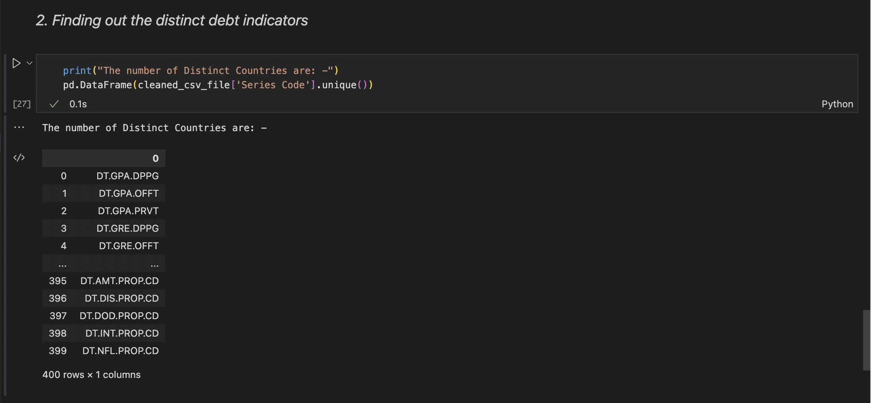

1. **Totalling the amount of debt owed by the countries.**

**Attached screenshot has the list of amount of debt owned by each countries**

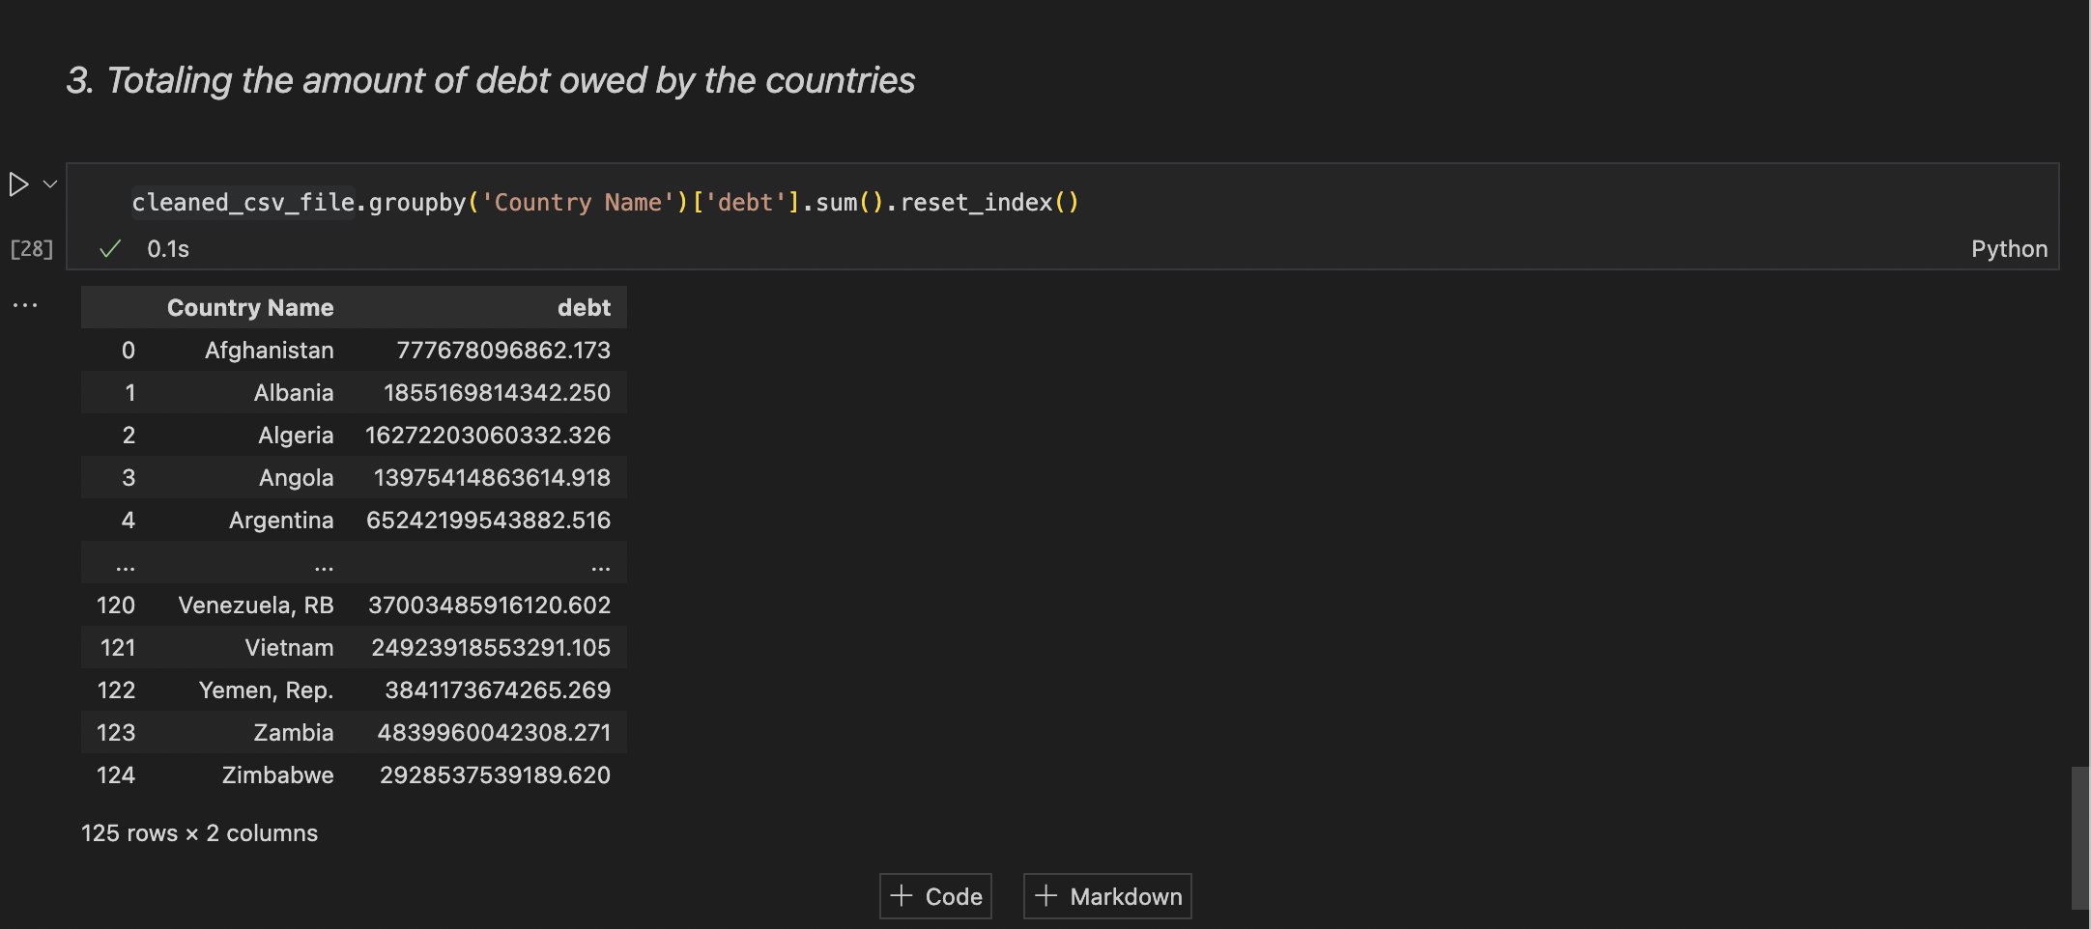

1. **Country with the highest debt?**

**China ( 377762854199707.438 ) has the highest Debt among all the countries in our dataset**

1. **Average amount of debt across indicators?**

In the attached screenshot, we can see the list of average debt across each indicator

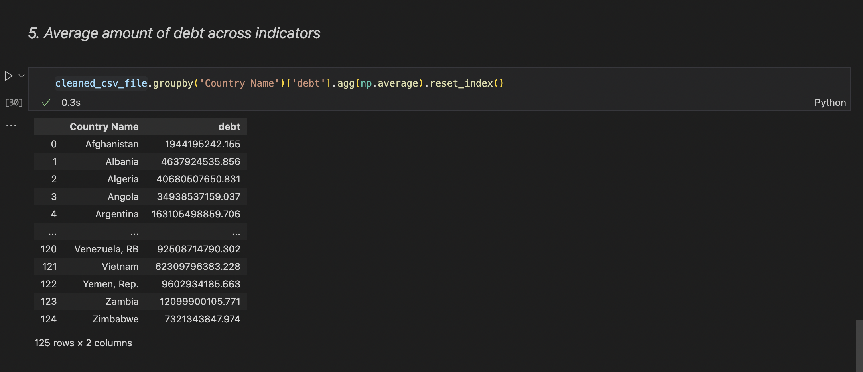

1. **The highest amount of principal repayments?**

In the attached screenshot, we can see the list of highest amount of principal repayments.

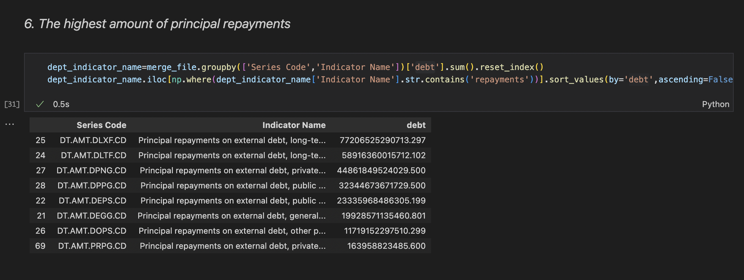

1. **The most common debt indicator?**

In the attached screenshot, we can see the list of **most common debt indicator.**

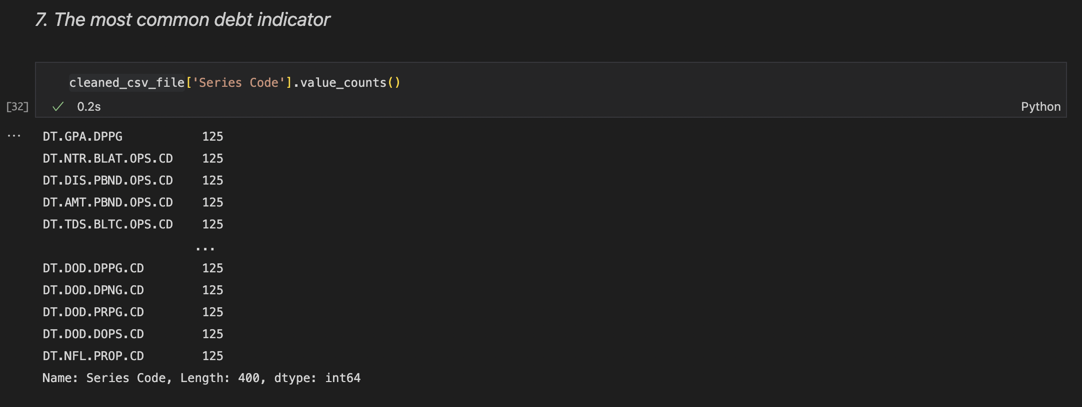

1. **Other viable debt issues and conclusion.**

In the attached screenshot, we can see the list of **Other viable debt issues.**

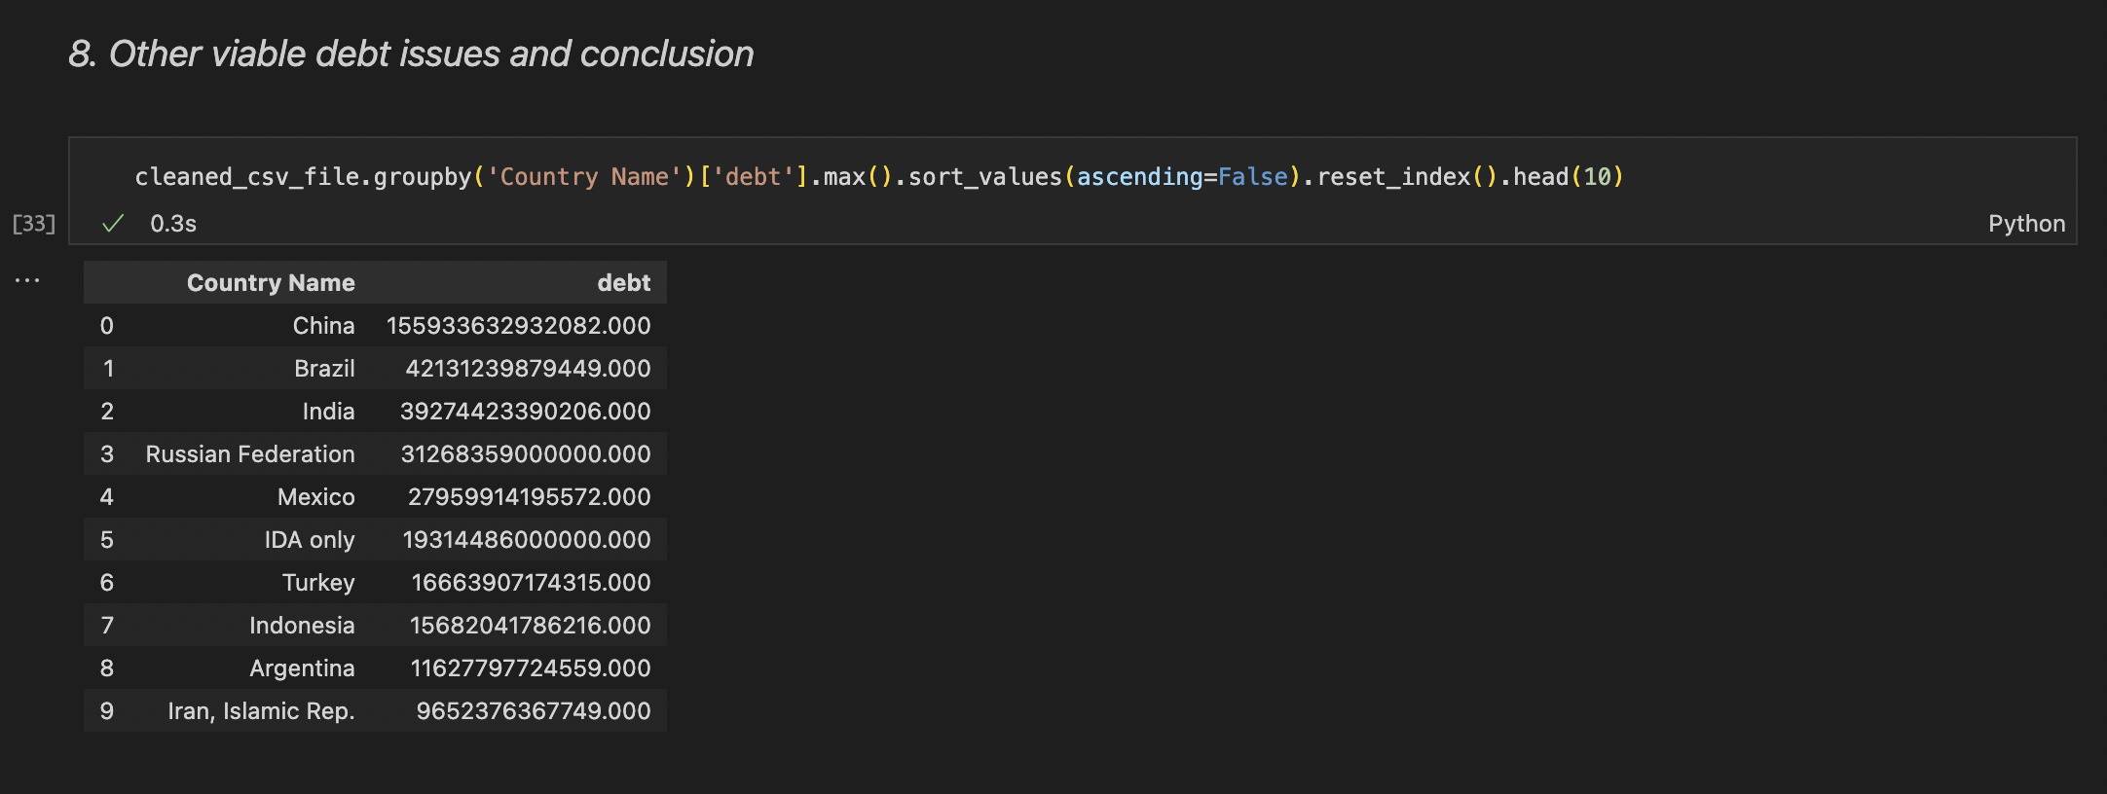

* Country having highest debt is China.
* The most common Indicator Name - DT.AMT.DLXF.CD and Series Code is 125.
* All Country Have Same 125 Debt Indicators Code.
* 128 Unique Country’s present in the Debt Analysis.
* 400 Distinct Indicators Name for Debt.

**TABLEAU**

**1] Demographic View**

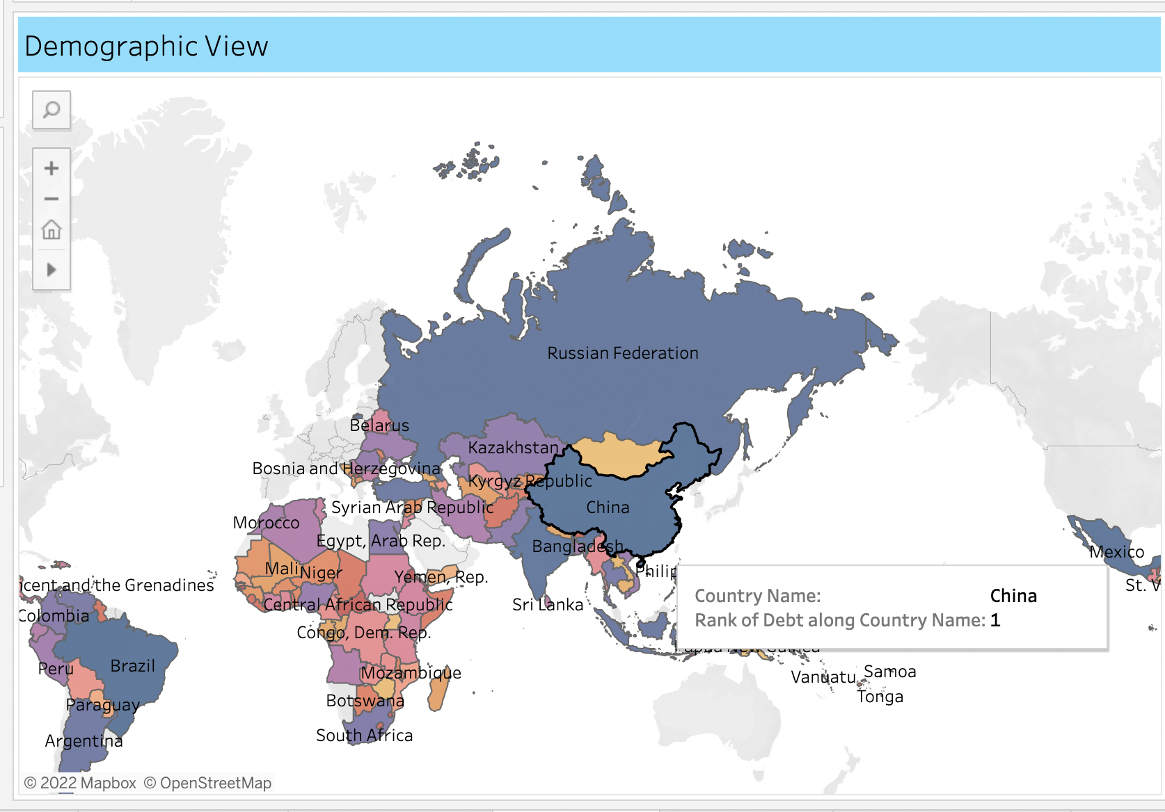

* Dark Blue indicates Countries having highest Debt among all the other countries.
* China Ranks 1st among all the countries.
* Orange or Red Colour indicates countries having the lowest debt.

2] Indicator Series Code Debt

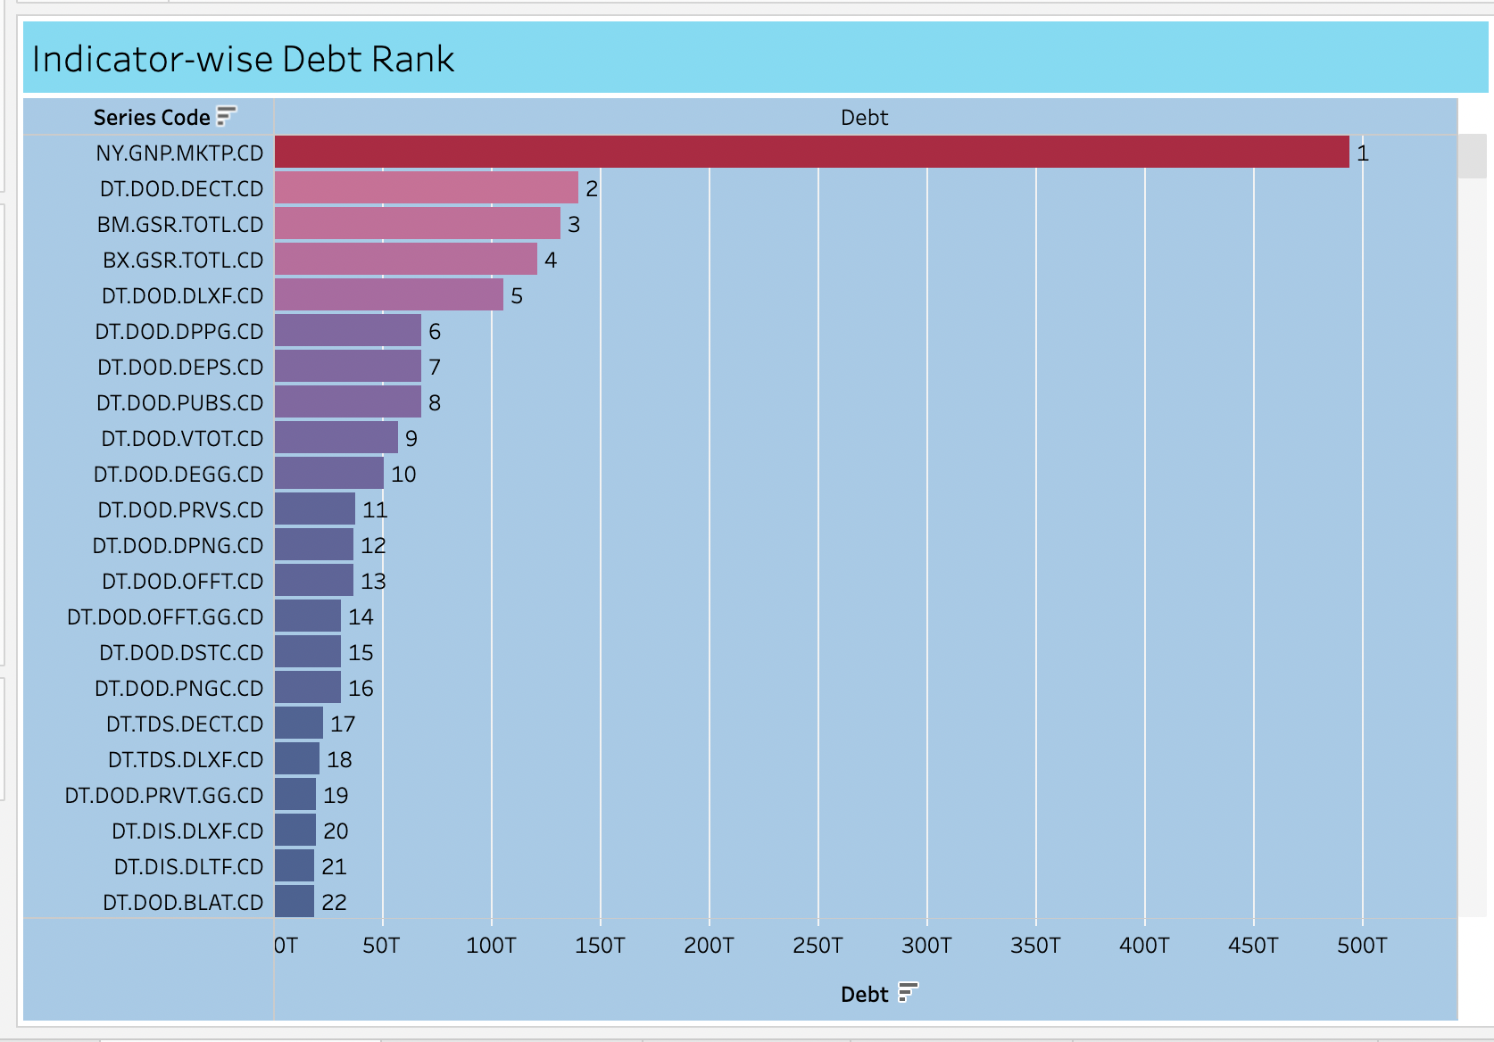

* Red Colour Stands for highest Debt a country holds in which Indicator.
* NY.GNP.MKTP.CD is the indicator Code for which debt has been taken by countries.
* Approximately 500T amount of Debt countries took in NY.GNP.MKTP.CD Indicator code.

3] Country-wise Highest Debt

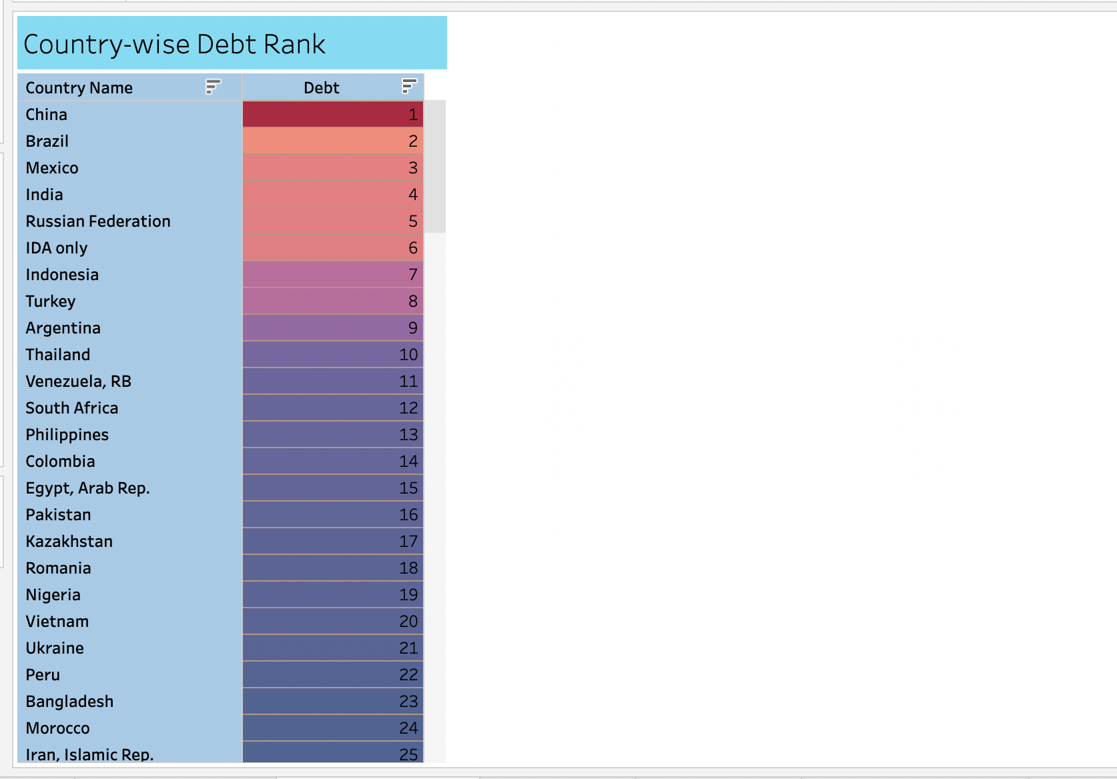

* Red Colour indicates highest Debt among all the countries.
* China stands first followed by Brazil and Mexico which stands for 2nd and 3rd rank.

4] Cumulative View for each Indicator Series Code for each Country.

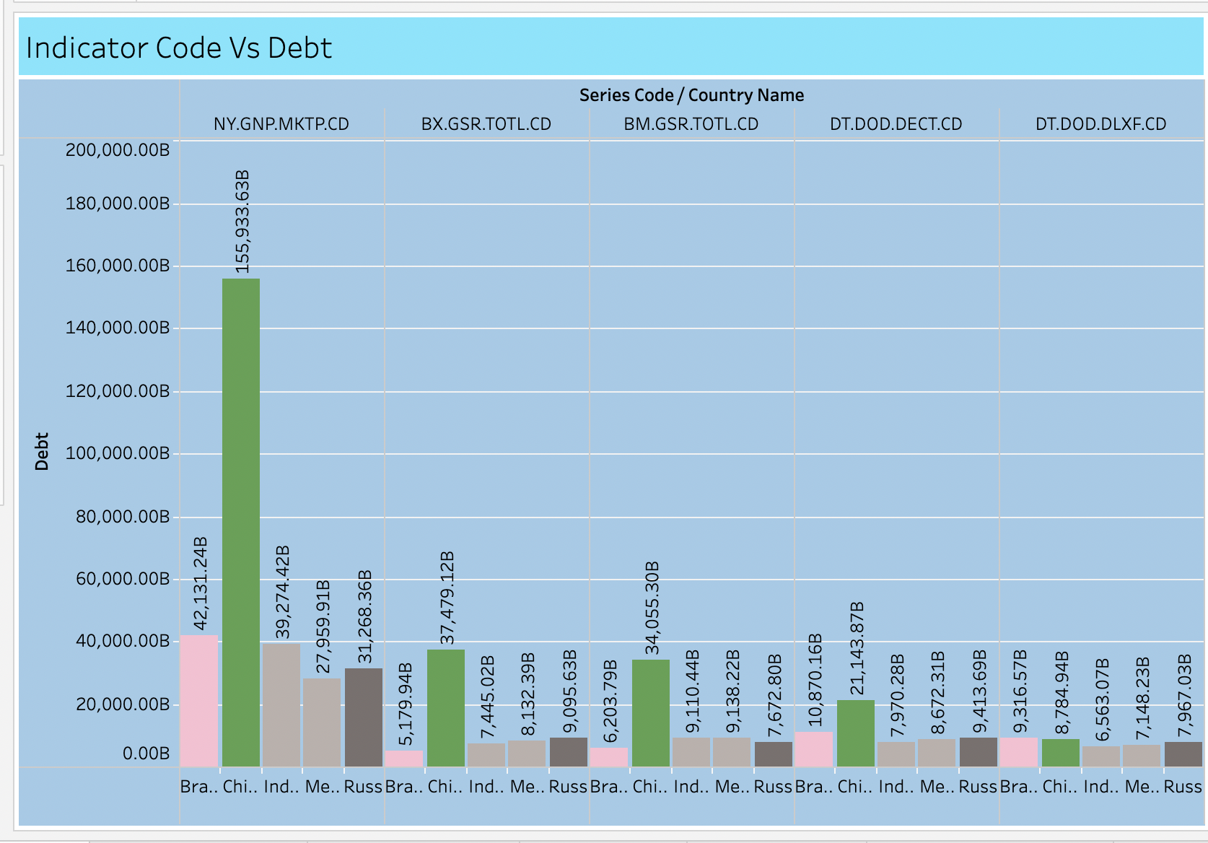

* In this Bar graph, we can see the top 5 countries having highest debt, how much amount they took for which indicator.

5] Dashboard

Below are the Dashboard, which is a collection of all data comprised in a single view by which we can easily collect the information we require.

